

MARKETS INFORMATION SYSTEMS
BUSINESS ANALYSIS
Change Request – Requirement & Solution Overview

TeamTrack CR #
BA Owner | Mark Russell
Primary Business Contact | Garrick Stavrovich
Short Description | Wave 2 Data Feed Access Declarations
SOU Date | 23/May/2011
Share Point Link | http://portal.emea.ime.reuters.com/sites/Sales_and_Service_Ops/Shared%20Documents/Forms/AllItems.aspx?RootFolder=%2fsites%2fSales%5fand%5fService%5fOps%2fShared%20Documents%2fCRM%20Business%20Analysis%2fPBI%20Overview%20Documentation%2fB2CC%20Wave%202%20Data%20Feed%20Access%20Declarations&FolderCTID=&View=%7b6BBBED1B%2dB0BA%2d4CA1%2d81E9%2d77324714A4BA%7d

Document Control
Date | Version | Author | Description
17/Feb/2011 | 0.1 | Mark Russell | Initial version for review

MIS Approval List
Name | Role | Approved Date
Amanda Lines | Global Process Manager
Garrick Stavrovich | VP, Global Business Operations, Customer Admin
John Spillane | Head Sales Process

Contents
Document Control 1
Contents 2
1. Problem Statement 3
2. Requirement Statement 3
3. Solution Overview 3
High Level Solution Summary 3
Impacted Applications 5
Impacted Processes 6
4. Use / TEST Cases (Impacted Processes) 6
5. Risks / Process Limitations 6
6. Further Requirements Not delivered 6
7. Appendix 6

Problem Statement

The B2CC wave 2 release will rollout SAP billing into the USA and Nordics and Customer Administration require the ability to invoice customers for orders raised as a result of Data Feed Access declarations (DADs) being returned to Thomson Reuters. Currently the DADS orders raised in the USA and Nordics are processed through core suite and the resultant assets are RCIP’d to Siebel, therefore no orders are raised through siebel for DADs activities.
In Canada (B2CC wave 1) there is already a process allowing DADs orders to generate invoices from SAP. The process is not sustainable for customer administration when SAP is rolled out to the USA due to the significant increase in manual work as compared with the previous core suite based ordering process.
In Canada there is a manual load of installed position data extracted from business objects and loaded into eDTK (electronic data feed tool kit) so it can generate DADs. Currently customer administration spend 20 minutes per day completing this manual extract and given that the USA has 8 times more data than Canada it will not be possible to manually extract the data from business objects.
Furthermore SAP generated invoices show the account ‘A’ numbers as implemented by the CDM project, DADs show the core suite subscriber numbers and sub accounts. This means customers are not able to reconcile the DAD declared to Thomson Reuters with the invoice they receive for that declared DAD. In Canada Customer Administration have added subscriber information onto most invoices so that customers are able to reconcile the DAD and invoice but this will impact customer satisfaction if the same approach is taken in the USA. Customer DADs should show the account numbers to allow customers to change their own systems and internal process away from subscriber number and sub accounts to the new account numbers.

Requirement Statement

As Customer Administration
I want the ability capture DADs returned to Thomson Reuters in the USA, Nordics and Canada. After capture the returned DAD should be converted into a quote that I can review and price before submitting it for billing in SAP.
So that SAP invoices can be raised for customers in these countries

Solution Overview

High Level Solution Summary

eDTK will continue to generate and capture DADs as the process is not being reengineered as part of this deliverable.
There will be a daily installed position load from a system with Siebel sourced data, the feed will load eDTK so that it has the ability to generate DADs with the correct product counts per subscriber. eDTK is a country based system (aligned to core suite instances) and will be expected to upload the data prior to the working day in the region in which it is based.
eDTK will capture DADs and OMS will trigger eDTK to create a draft quote in Siebel. A generic draft quote interface will be developed so it can be reused for other create quote requirements so eDTK will send the draft quote message to EAI that will pass it onto Siebel. Siebel will raise a draft quote and
- Calculate the quote header Legal Entity because eDTK only knows subscribers
- Automatically map PLIs for installation line items based on given PDP code
- Automatically map assets for cancellation line items based on the lowest price asset, that is being billed, where the PLI maps to the PDP code
There are no modify operations in this process because all of the PLIs are billing only and therefore do not require permissioning or technical fulfilment.
OMS will review the draft quote to ensure that the right products and assets are mapped onto each line item. If a quote is created with > 1000 line items OMS will copy the quote and delete line items from both quotes to ensure that there are less than 1000 line items. OMS will click price quote and if no custom deals are setup they will need to add special prices to the line items. OMS will then validate, approve and submit the Zero Touch quote and siebel will process the order through to completion.
As part of approving the quote the OMS will notify sales of the revenue impact generated as a result of the DAD. The notification will go to all account managers on the billing accounts associated to each quote line item. There will never be update opportunities from siebel to trust as part of this process.
The diagram below shows the high level process overview and actors (systems and people) for wave 2 DADs although this does not include generating the DAD from eDTK as this process does not change for wave 2.
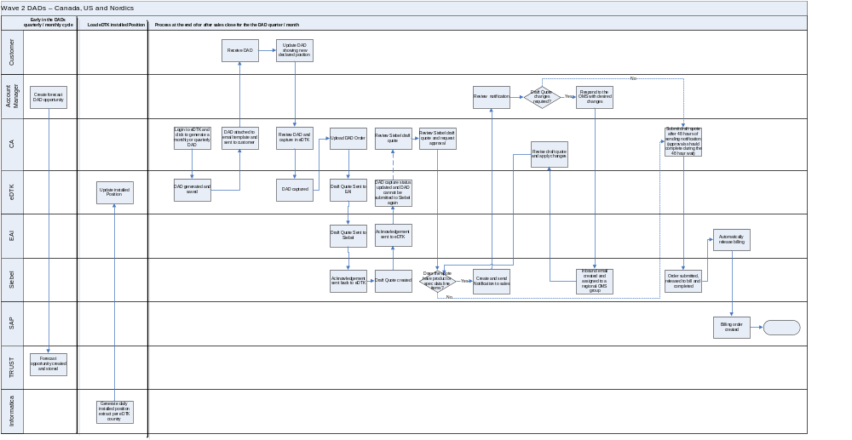
Given that the current core suite ordering process is being migrated to Siebel this will increase the volume of orders processing through the CRM application. The graph below shows the number of order line items processed through Core Suite in 2010 for DADs in the USA and Nordics that Siebel and SAP must process following wave 2 go live.

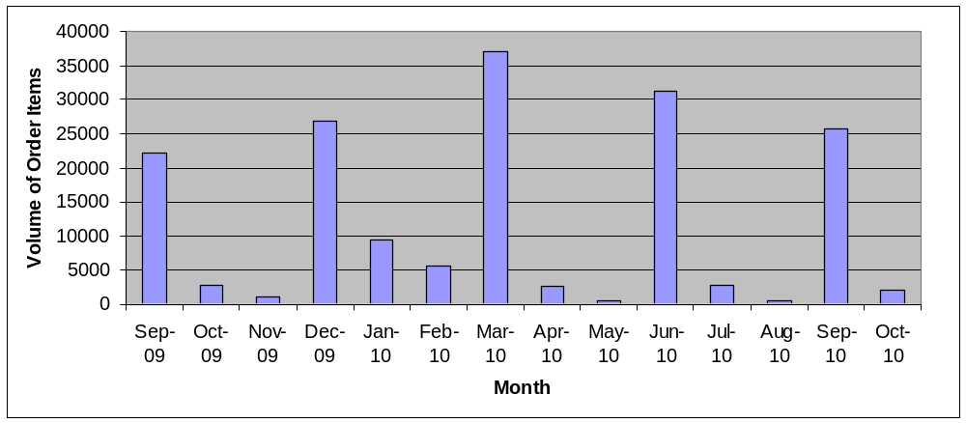

The above volumes are per month and the weekly breakdown is shown below, all DADs should be processed before sales close in the month.
- 10% in the first week of the month
- 30% in the second week of the month
- 60% in the third week of the month (sales close)
Customers can return DADs late that will result in sales either only processing the installations, not the cancellations before sales close, or the OMS processing them after sales close although this is rare and does not impact sales.
To ensure that Siebel is capable of supporting this increase in order line items a performance plan is being defined and executed so we are confident that the process will meet operational needs.

When wave 2 goes live this process will be used by 100 SOMS staff in St Louis, most of them will never have processed a DAD before. Customer administration will be training them on the process prior to the go live of this functionality.

Impacted Applications
Siebel
- A generic create quote interface used by this project too enable a DADs process to create draft quotes
EAI
- A generic create quote interface
Informatica
- Daily asset extract file for consumption by eDTK US, Canada and the Nordics
- An account update interface*
eDTK (Delivered by Satyam)
- New interface to upload quotes into Siebel
- New interface to accept account updates from Siebel*
- Ability to show account numbers on the DAD*
- Deploy code to generate the Canadian DAD difference report in the USA eDTK instance

* CA and MIS are finalising the requirement for how to show the SAP account numbers on a DAD so that customers can reconcile their SAP invoice to the DAD. When this is complete these deliverables will need to be defined

Impacted Processes
Quote to Order – a new generic entry point into the existing quote to order process is being built to allow Siebel quotes to be raised from external applications, in this case from eDTK.
Reporting – feeding the installed position information into eDTK

Use / TEST Cases (Impacted Processes)

Customer administration will assist MIS to define the QA and UAT scenarios to ensure that the quality assurance is targeted for success.

Risks / Process Limitations

Risk | Mitigation
Ensuring the new eDTK to Siebel quote interface will support the process and transaction volume | Non functional testing plan will be impleplemented as part of this project to identify and resolve system bottlenecks
The wave 1 eDTK installed position data load process cannot support the asset volumes per account | This is being tested with the largest US clients to identify issues and plan for their resolution
The effort for delivering functionality to show account numbers on DADs does not align with the delivery plan | Identify the constraints with Satyam to see if it can be delivered within the delivery plan
Satyam identify constraints risking delivery within the plan | Satyam will review the plan to identify risks, issues and dependencies in the scope of work
Core suite will continue to feed eDTK information when this functionality is live | Work will be required to move these interfaces off core suite. This will be required before compass can be retired.

Further Requirements Not delivered

GPA will want to manage PDP codes and their mapping to PLIs in SAP, currently they manage the PDP codes in eDTK and data feed PLIs in core suite. Although GPA are happy to continue doing this in the short to medium term in order to close core suite the PDP management process will need to be moved.

There are other interfaces from Core Suite to eDTK that will need to be moved if core suite is going to close, the following list are the data points that core suite will continue to feed into eDTK
- Account Address
- DAD account contact
- Responsibility code – Account team ‘Client Administrator’ and ‘Data Feed And Exchange Administrator’ team members

Appendix

